Assignment #2 – Inventory Hell
Problem Statement:
Problem: The number of items vastly outweighs the number of worthwhile items. The tedium surrounding the unimportant items takes time away from doing more interesting things.
Problem Statement: Provide a solution to the handling and storing of the less important inventory items, thus streamlining the use of important ones.
Solution to Problem:
My solution to this problem is two-fold. I would first address some problems with the user’s inventory. I would add slot customization to each of the hot-bar slots. To do this, players would shift-right click on whichever hot-bar slot they want. Each slot could be edited to specify which items may go to that slot when picked up (up to nine items). For example, you could specify that you want only iron swords to go to slot 1 when picked up. This would help to make it so that players hot-bars are always filled with an item assortment of their choosing. This would also accommodate other players who don’t care about which items enter their inventory or where.
The second part of this solution involves creating a new item to attach to chests, the vacuum jewel. The player would have to craft this item which would involve another new item, the potion of vacuum. When consumed, the potion of vacuum would pull items in from farther away while it’s effect is on the player. The player may brew this item by taking a snowball and brewing it with an awkward potion (fig. 1). They then take the potion, a block of Redstone, three iron ingots, and two leather to make the jewel itself (fig. 2). With the jewel in hand, the player shift-right clicks on the chest. Once they have done so, the player can right click on the jewel, now visible on the chest. In the menu they can specify up to five items. The items they select will be pulled into the chest from the player’s inventory when the player walks by. The animation for this is the chest opening up when the player approaches. When the items are leaving the player’s inventory they would see the item drop going from their player character into the chest with a vortex effect. The chest can still hold items that aren’t specified in the vacuum jewel menu but they won’t be pulled in when the player walks by.
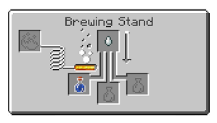
Potion of Vacuum Recipe (fig. 1):

Vacuum Jewel Recipe (fig. 2):
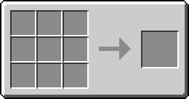
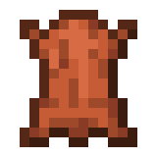
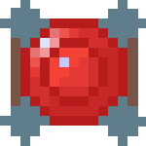
Wireframes Pre-Pivot:
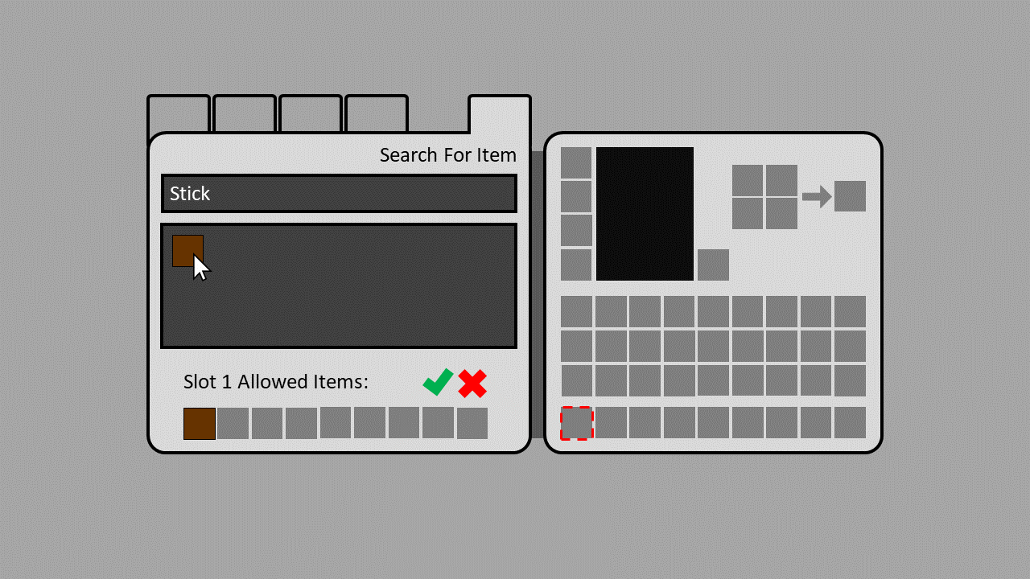
Hot-Bar Settings Menu:

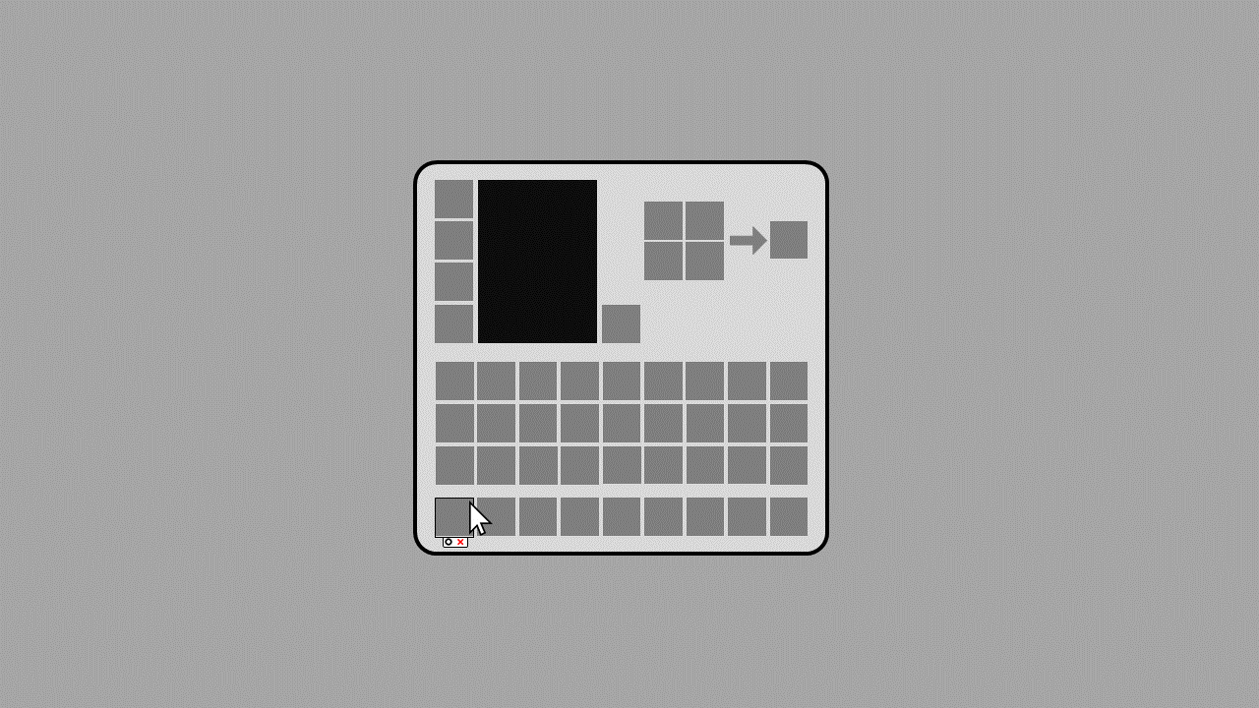
Hot-Bar Options UI:

Documentation of User Testing and Research:
I interviewed Justin Chambers, Zachary Logsdon, and Michael Crouch. Zachary liked both aspects of the solution. He did say that the hot-bar settings may make the game feel more RPG-like. Similarly, he said that the chest item may not feel very vanilla Minecraft. He did also say that he hasn’t played the game in a couple of years though. Justin liked the idea but commented that it might be difficult for players using controllers to use. The typing would take a much longer time to do on a console. Michael liked the ideas altogether. He liked the hot-bar idea because it made it so items that players don’t want going in their hot-bar wouldn’t end up there. He liked the chest idea because he specifically likes to take all of his non-ores and put them in the furnace after mining. He said he could then go home, walk by his chests, get rid of all his non-ores, and be ready to go mining again really quickly.

Design Pivot:
Pivot Details: Add loadouts for the hot-bar. Using these, players can make up to three hot bars that have items in different orders. For example, these could include a hot-bar for building, crafting, and mining.

Solution to Design Pivot:
I wanted to design a solution to the loadouts pivot that preserved the customizability of my hot-bar design. For example, I wouldn’t want to define the only items which players could select for the “building” hot-bar. To do this I would add an additional enchantment called Inventory. There would be an Inventory I and Inventory II enchantment. This enchantment would give you one additional hot-bar at enchantment level I and two at enchantment level II. These hot-bars would also serve as an additional two rows of inventory space. This enchantment would only be available to put on chest plates. It would allow players to continue to pick their allowed items in each of their three hot-bars. They could then select their hot-bar by clicking the 1, 2, or 3 button to the left of the hot-bar row in the inventory menu. In addition, they could select a banner to decorate their hot-bar with. This banner would allow players to contextualize which hot-bar is which when they aren’t in their inventory menu. Players could also switch hot-bars while in game by using X. This might make it easier to understand as X is the same key used to swap hot-bars in creative mode. Pressing X would cycle to the next hot-bar in the order it is listed in the inventory menu. For example, if the player pressed X while on hot-bar 2 (which was themed with a building banner), the hot-bar would be switched to hot-bar 3 (which is themed with a mining banner). If a player dropped their chest plate or they unequipped it their items in the additional inventory slots added by the new hot-bars would be moved to the normal player inventory. If their inventory was full they would drop the items on the ground.

Wireframes Post-Pivot:
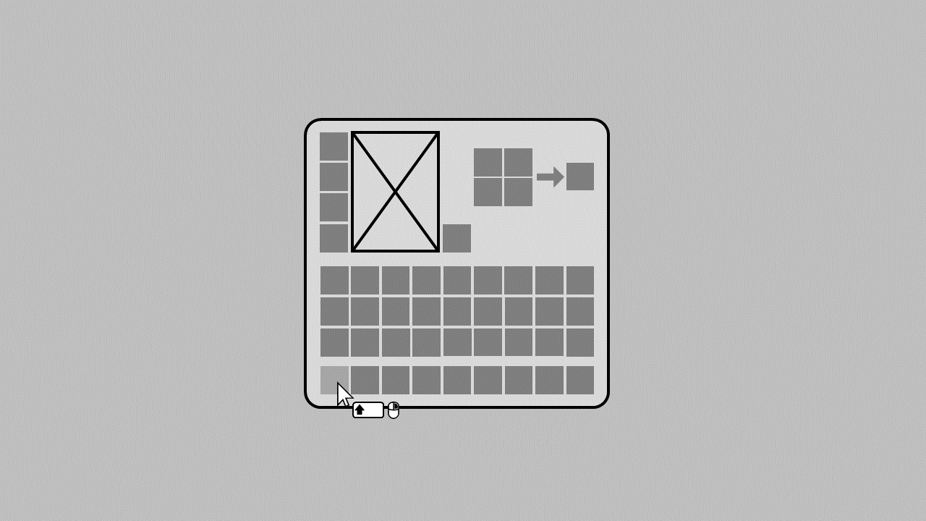
Hot-Bar Options UI:

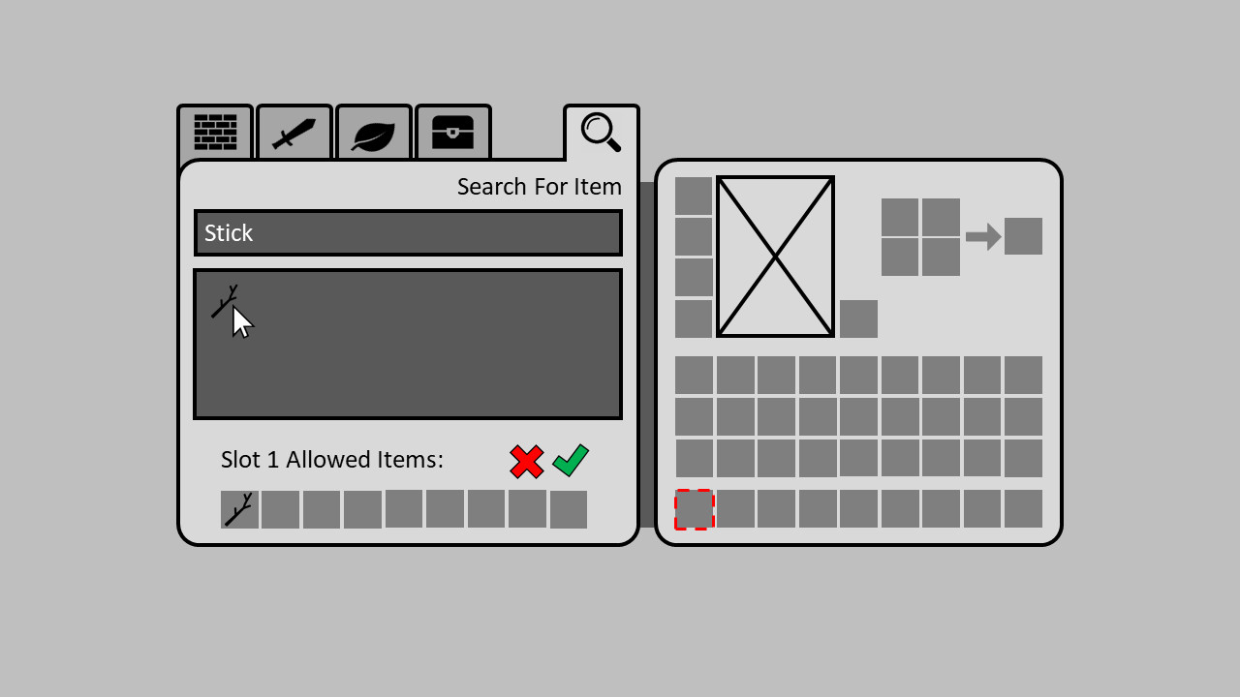
Hot-Bar Settings Menu:
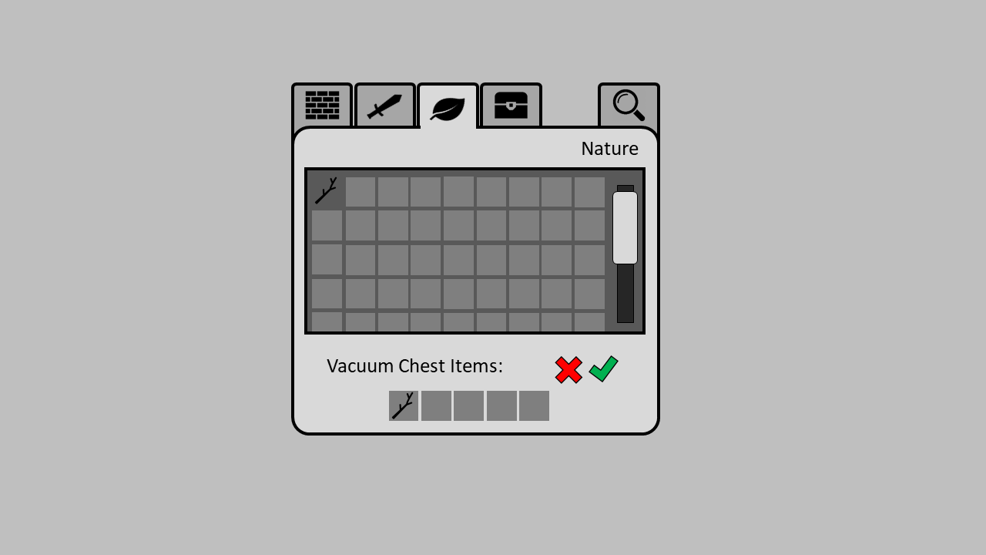
Vacuum Jewel Chest Menu:

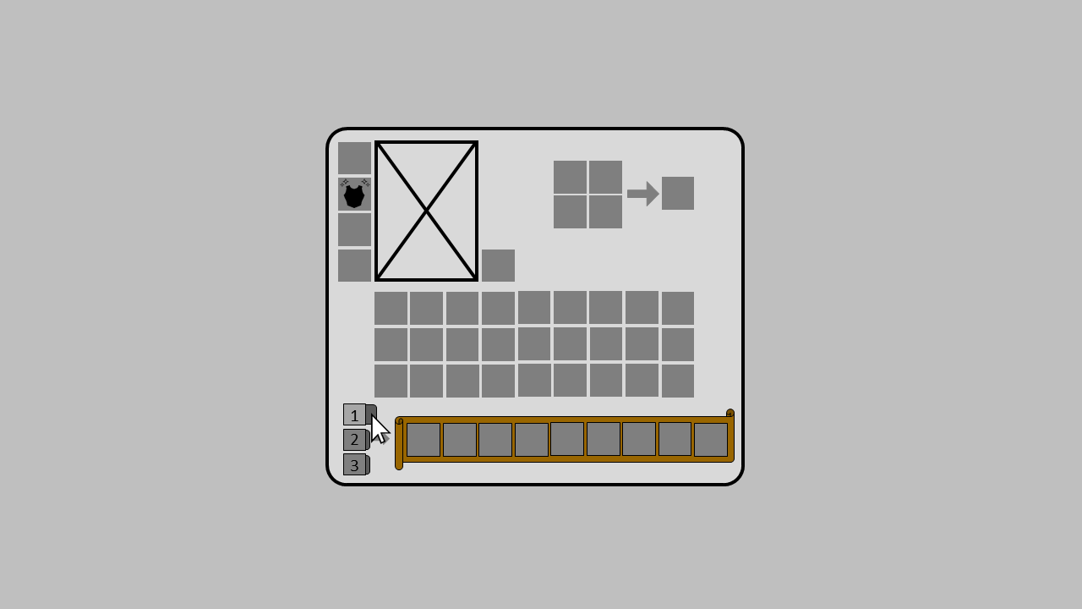
Inventory with the Inventory II Chest Plate Enchantment (Loadouts):

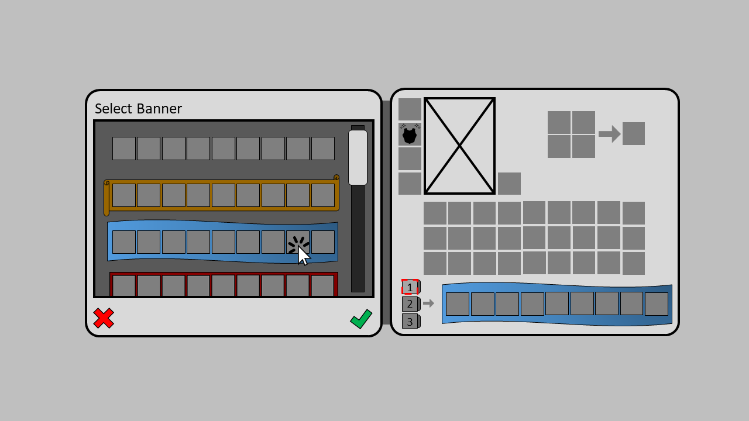
Hot-Bar Banner Select Menu:

Documentation of User Testing and Research:
I wanted to see what some users though of my design changes post design pivot. I interviewed Michael Kinyon and Connor Shea, both of which have plentiful Minecraft experience. Michael liked the design of the feature but said he couldn’t see it being added to vanilla Minecraft. Michael did comment that the feature could be done in a better way. He said that some of the mods he plays with do something similar but better. After explaining that I wanted to make a change that was purposefully limited but still a quality of life improvement, he began to see the potential for it being in vanilla. I said that I didn’t want the change to remove the fun elements of the inventory system by making it too easy to sort. Connor liked the changes as a mod idea but still held that the changes wouldn’t feel vanilla enough. Michael helped me to realize that I would need a different button for opening the hot-bar slot customization menu. Right click in Minecraft takes half a stack. I changed it to shift-right click. He also helped me to work out a better solution as to how to implement the loadout system. He said to add an item that when held gives the extra hot-bars. I instead re-worked this into an enchantment.

